Report 13th September 2018

1. **Call Java simulator from R**

Done: created functions in R to simulate from the model and read in data (file “PseudoFunctions.R”)

1. **Extracting summary statistics for each output**

* ***How do outputs evolve over time? What are the relevant features/ summary statistics?***
* ***How do outputs evolve as parameters change? What are the relevant features/ summary statistics?***

Given that the simulator is stochastic, we might need to produce averages of outputs to see patterns more clearly.

* ***Global inhibitor (GI):***

Created boxplots of the GI and ordered them according to each parameter to see if any patterns emerged.

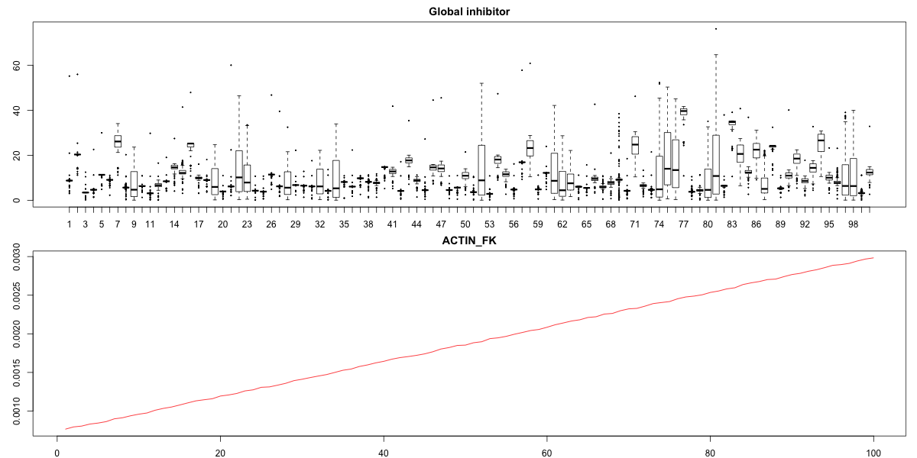

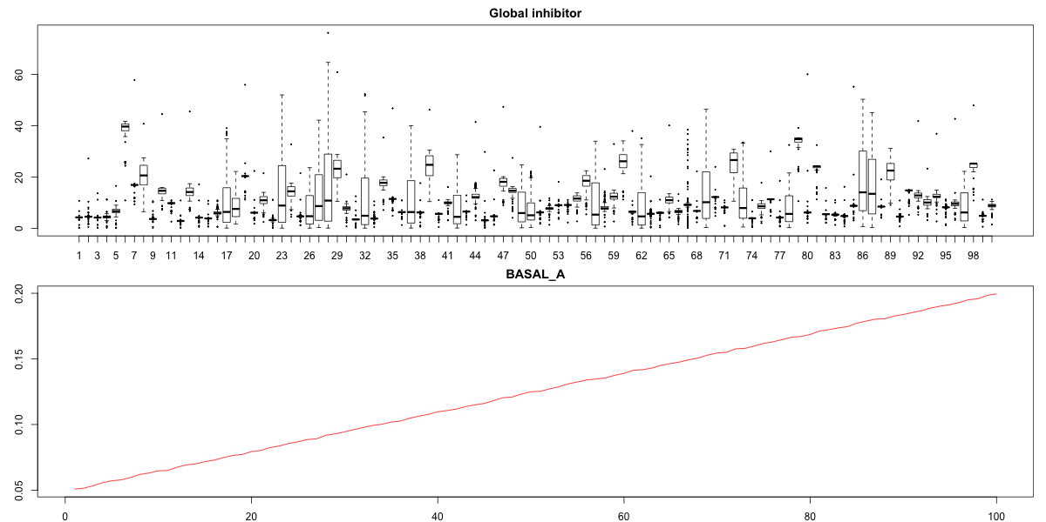

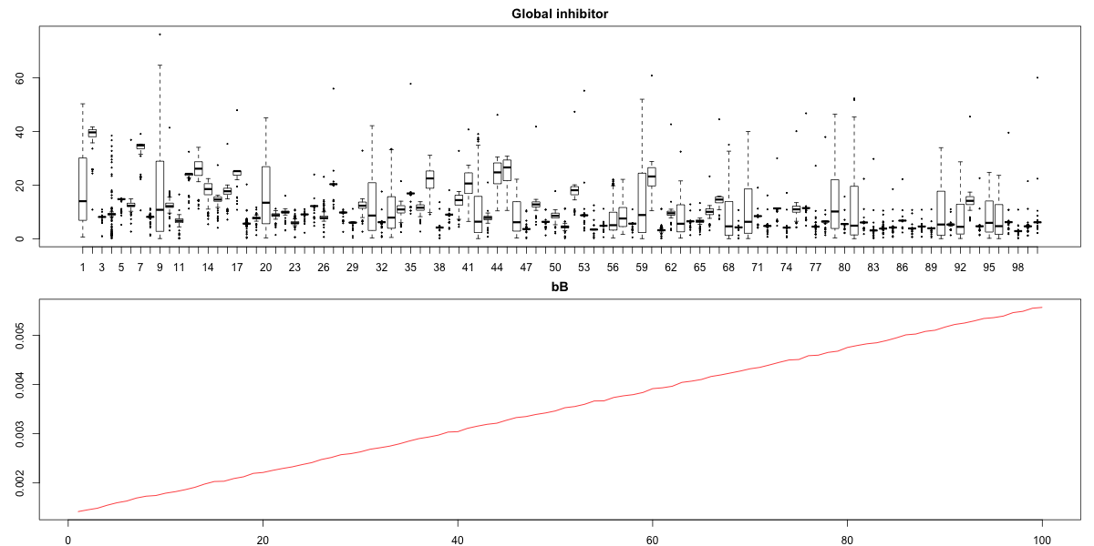

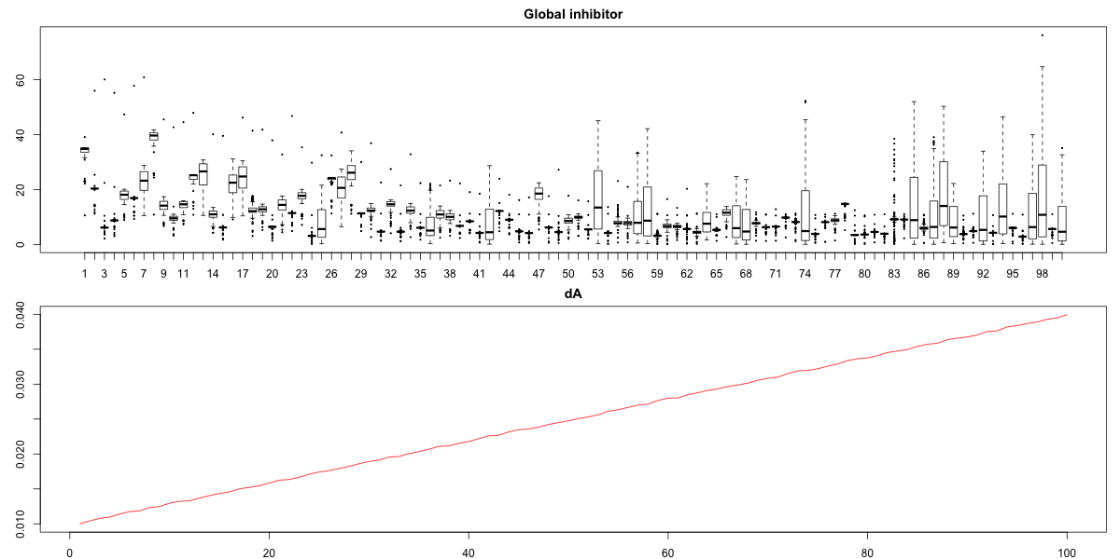

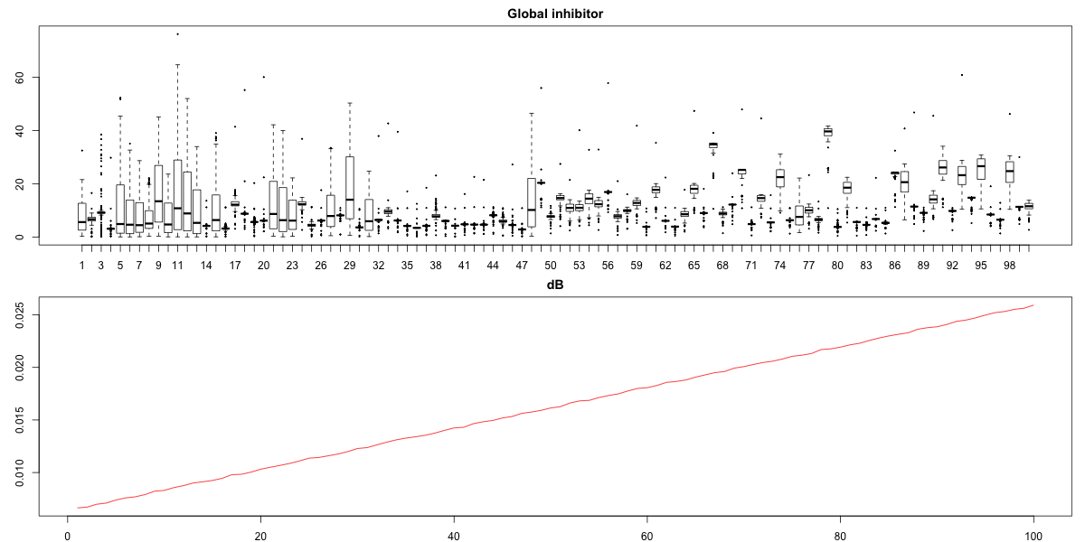

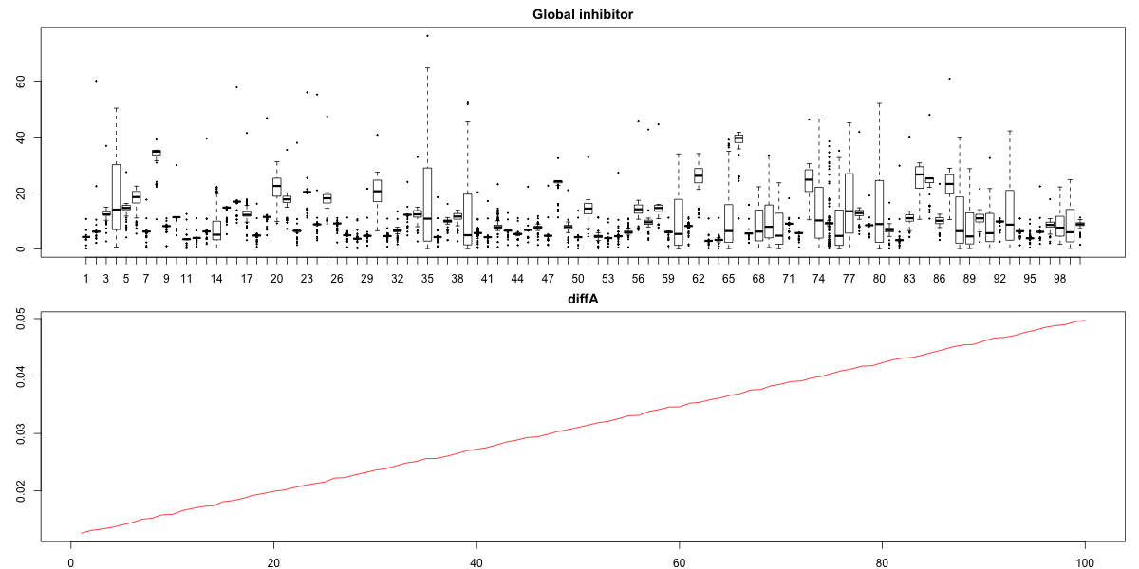

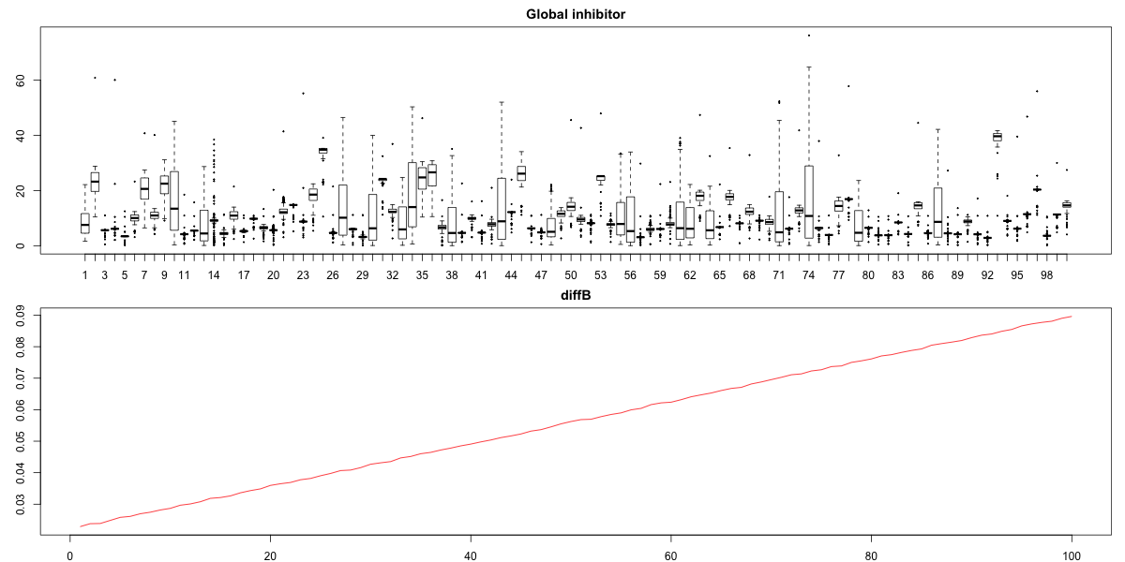

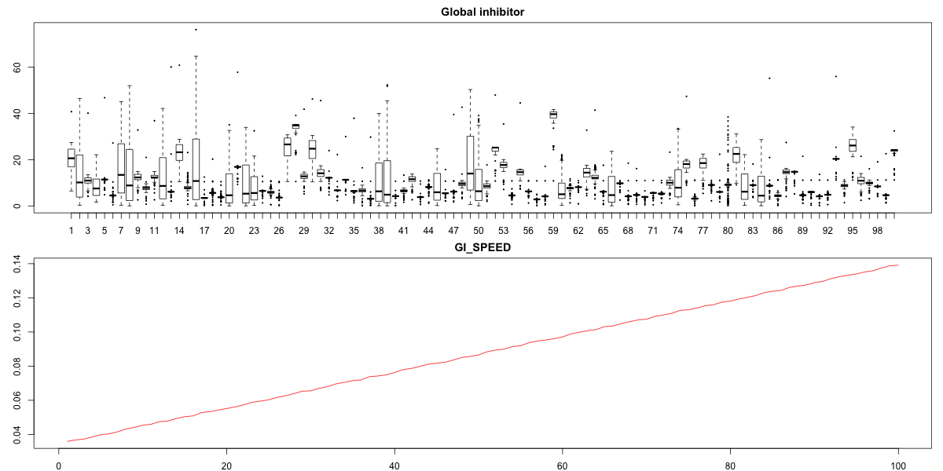

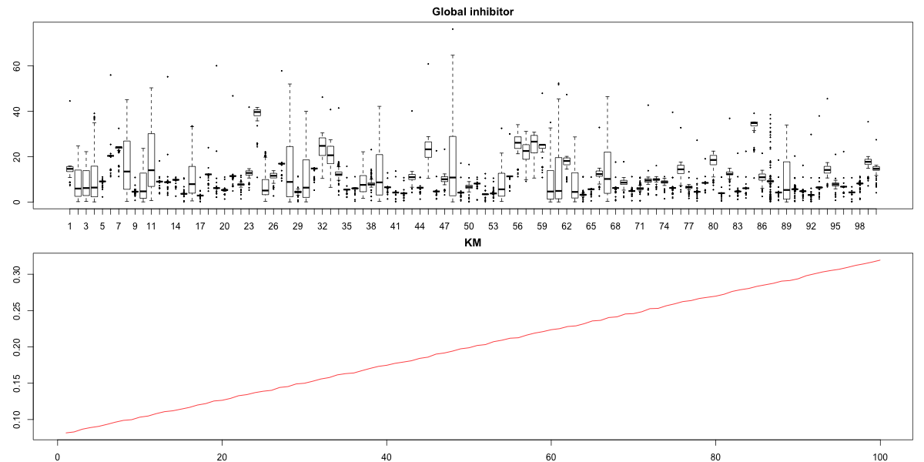

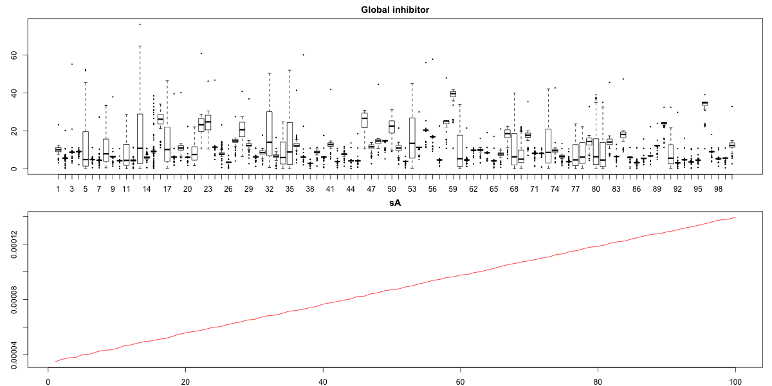

1. **Run local and global sensitivity analyses using the summary statistics.**

Identified package “sensitivity” in R that performs local and global sensitivity analyses, variance- or derivative- based methods available.